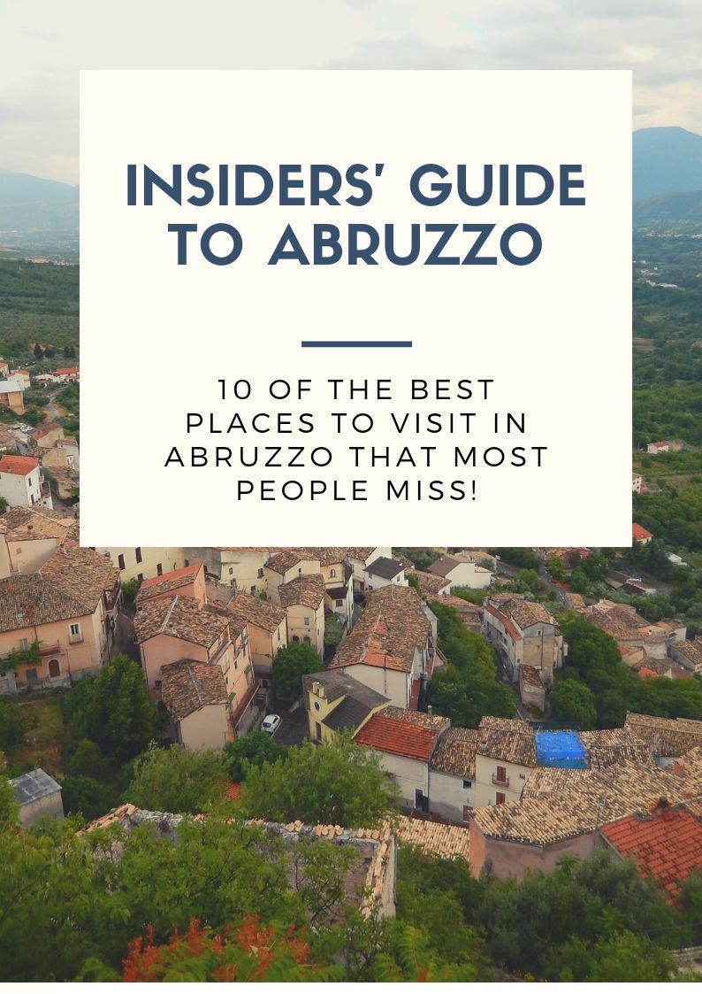
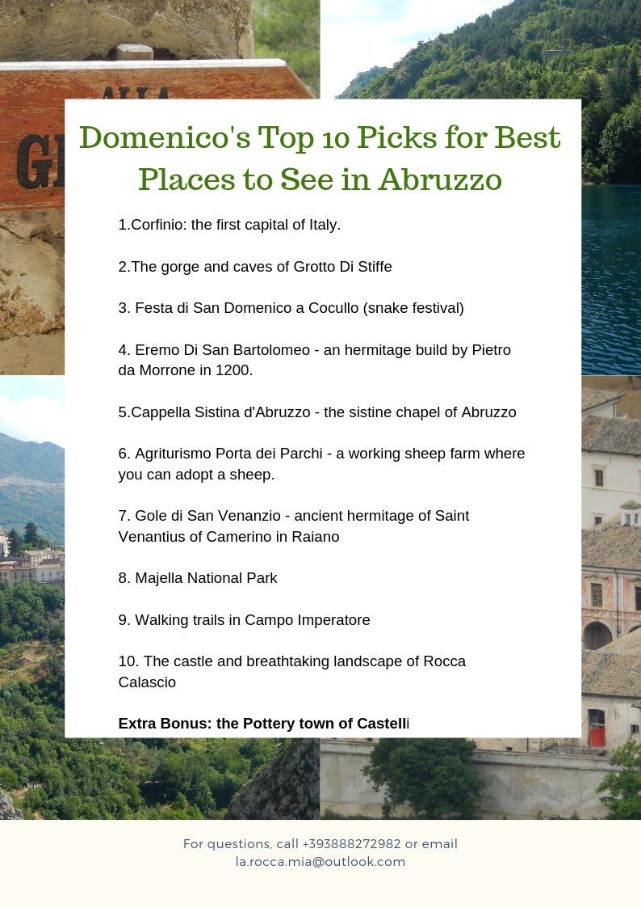Introduction
In this guide we share 10 of the best places to visit in the Peligna Valley located in the region of Abruzzo in central Italy.
Abruzzo stretches from the Adriatic Sea to the Appennini Mountains. It is known as "the greenest region in Europe" as almost half of its territory, the largest in Europe, is set aside as national parks and protected nature reserves. The Peligna Valley is in the middle of this incredible region.
It is filled with amazing sites that most people miss when traveling to the area. Domenico has lived in this amazing area of Italy all his life and has extensive knowledge because it’s his passion. He has put together his top 10 places to visit in Abruzzo!
So without further ado, here they are!

#1. Corfinio
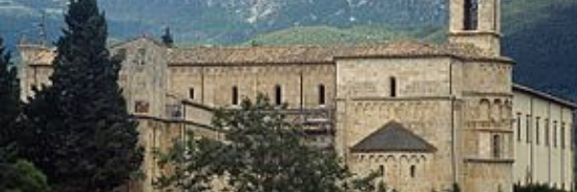

Did you know that Corfinio was actually the first capital of Italy? This lovely Roman village is located right in the middle of the valley. In this village you can find the church of San Pelino, a medieval church built by the Lombard Princes and then completed by the Normans.
It is the largest medieval cathedral in central Italy. The Museum Antonio De Nino contains important relics of local and national history. The first coins bearing the word ITALIA (first epigraphic attestation of the name) were minted here.

#2 Grotte Di Stiffe
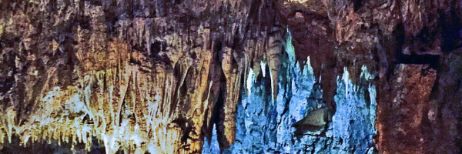

Grotte Di Stiffe is located at the top of the gorge that overlooks the small town of Stiffe. The Stiffe Caves include a spectacular karst (landscape) phenomenon characterized by the presence of an underground stream formed by the waters coming from the Plateau delle Rocche, which then sinks into the river Pozzo. The stream re-emerges inside the cavity ending in a waterfall.

#3 Festa di San Domenico di Cocullo
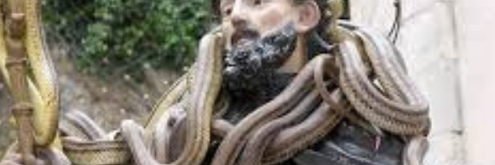

This festival occurs annually on May 1^{st.} in the town of Cocullo. The slithery ritual, the Festa dei Serpari or Serpent Festival, features locals parading the streets with scores of snakes.
Handled by specialist called serpari, the snakes are draped around the statue of San Domenico di Sora, the patron saint of Cocullo. The procession begins at midday with four people carrying the statue of San Domenico from the church through the narrow streets. After the procession the serpari retrieve their snakes and release them back into the wild – until the next year.
#4 Eremo Di San Bartolomeo
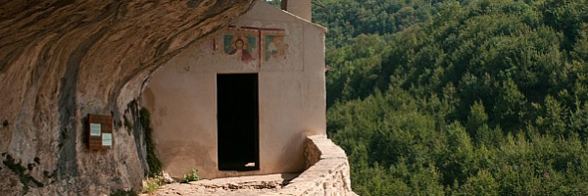

The Hermitage of San Bartolomeo is in the village of Legio in the Giumentina Valley. The Hermitage was built by Pietro da Morrone in 1200BC. Today, many centuries later, pilgrims travel to worship at the Hermitage.
The Hermitage consists of a chapel and two rooms carved into the rock by hermits. The façade of the church has frescoes and inscriptions that have been severely damaged by the weather. The portal of the church consists of a simple stone architrave.

#5 Capella Sistine d’ Abruzzo
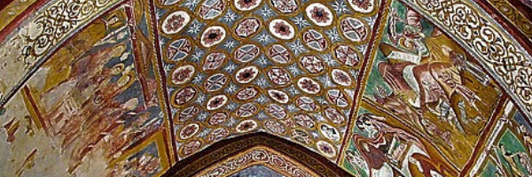

On the regional highway 17, shortly after the village of Navelli, to the north lies the village of Bominaco. Once a busy center and now a village of just over 50 people who preserve a treasure of extreme value. Bominaco includes a complex of monumental churches, and a former Benedictine monastery with a small church completely frescoed. Here you can admire the famous ancient painted Bomanic calendar.

#6 Agriturismo Porta dei Parchi
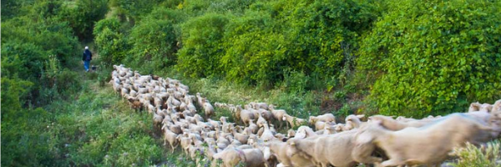

This local, organic, family owned sheep and goat breeding farm is located just outside the quaint town of Anversa.
Here you can enjoy walking with the shepherd, visiting the animals, making cheese, and (you can even) surprisingly adopt a sheep. They also have a restaurant where you enjoy farm to table Italian cuisine.

#7 Gole di San Venanzio
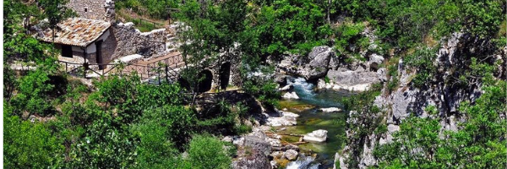

The ancient hermitage of Saint Venantius of Camerino is situated above the river Aterno, in a remote ravine a few kilometers north of the town of Raiano.

#8 Majella National Park
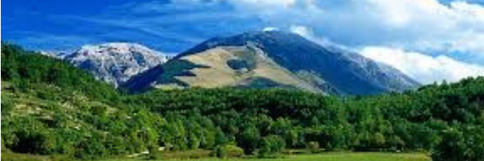
The Majella National Park is extraordinarily rich in wild nature and animals as well as historic, archaeological and architectural sites. It has been inhabited since the Paleolithic era, 800,000 years ago. The park is 242 sq. mile and its highest peak is 2,795 meters.
Many of the Majella Mountain animals are protected, including the Apennine wolf, the Marsican brown bear, the Apennini chamois and several species of deer. There are visitor centers in various areas where you can find out more information about visiting the animal reserves.

#9 Walking trails in Campo Imperator
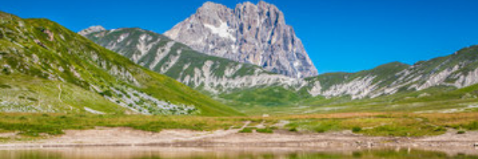
A must for visitors to Abruzzo is Campo Imperatore located in the Gran Sasso National Park. Campo Imperator has the distinction of being Abruzzo’s highest Alpine meadow. At 80km2 it’s the perfect spot to visit for nature lovers and photographers on holiday in Italy. The hiking trails are suitable for all levels.

#10 The castle and breathtaking landscape of Rocca Calascio
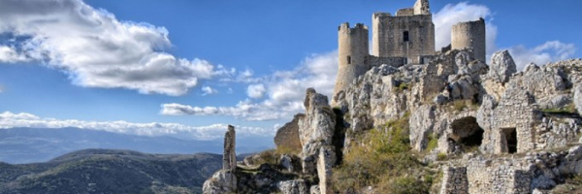
Rocca Calascio is a small town in the Province of L’ Aquila. Behind the town, you can admire the beautiful landscape of Campo Imperatore and in front of it, you can see the wonders of the Majella and Sirente Mountains. It is the highest town in central Italy.
Rocca Calascio and its castle were film sets of many famous movies, including “Ladyhawke” (with Roger Hauer and Michelle Pfeiffer), “The Name of the Rose” (with Sean Connery) and some scenes of “The American” (with George Clooney).

Bonus
Castelli “Capital of the traditional ceramics of Abruzzo”
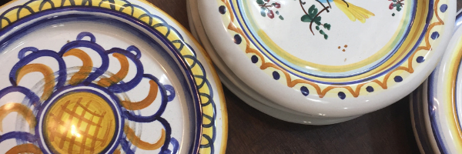
In the Middle-ages, taking the clay from the surrounding territory, a community of Benedictine Monks started a flourishing production of ceramics. Castelli than became home to famous masters who served the Kings of Naples and the noble houses of Rome. Every summer, Castelli hosts a ceramic handicraft exhibition-market that traditionally ends with the “throwing of the plates”.

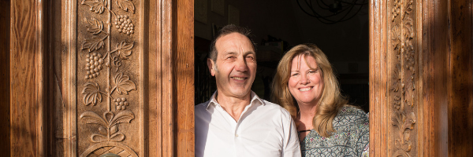
Let us introduce ourselves to you.
We are Domenico and Margaret and are the proud owners of La Rocca Mia House B&B in Roccacasale, Italy. Domenico is a native to this area. He loves sports, walking in the wilderness and getting close to nature. His passion is preserving the traditional way of Italian life. Margaret has moved here after retiring from an international teaching career. She loves cooking and hosting parties.
La Rocca Mia House B&B is a unique bed and breakfast accommodation in the heart of traditional, unspoiled Italy that provides personalized travel experiences for incredible prices.
Fun-Loving Adventurers
If you are a fun-loving adventurer who wants to experience the 'real' Italy but don’t have the time in your busy schedule to research and plan your perfect Italian escape. Don't panic. We are here to organize and arrange everything for you- no hassle, no worries, and no missed hidden treasures! You will experience everything this beautiful region has to offer - the culture, the cuisine, the countryside, the villages, the local arts, and the heritage.
You will enjoy a relaxing stay in one of our cozy, comfortable, clean, and uniquely decorated rooms with outstanding views across the valley to the mountains and over our charming garden to the village castle. You can choose from an amazing breakfast menu sourced from local farmers each morning, with everything freshly cooked to order just how you like it. And then you'll be taken out each day to enjoy amazing experiences that will exceed your expectations.
​
What makes us different?
With our help, you truly get to live the Italian life. Your stay will be tailored to perfectly match your interests, preferences, and budget. Domenico will be your own personal, Italian guide and his excellent local knowledge and passion for Abruzzo means you will experience and enjoy the 'real' Italy. You will be taken to the best places, introduced to hidden gems known only to the locals and experience the warmth of a true Italian community.

Call us on +39 3888 272982 or email us at la.rocca.mia@outlook.com
Don’t forget to visit our website www.laroccamiahouse.com for more information about an authentic stay in the heart of unspoiled Italy.
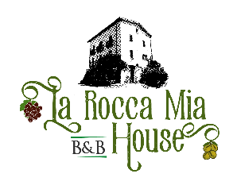
Warm Wishes,
